# GameFi 2021 Development Report

Contents

GameFi 2021 Development Report 1

1. About GameFi 2

1．GameFi Concepts and Development 2

2．GameFi Considerations 2

1. GameFi 2021 Industry Development Trends 3

1．GameFi Industry Position 3

2．Timeline of Key Events 6

3．How GameFi Developed Rapidly 6

4．GameFi Competitor Development 7

1. 2021 Classic Blockchain Games 10

1. Win to earn game——Axie infinity 11

1.1. Win to earn game——Thetan Arena 12

3.1 Stake to earn game——DeFi Kingdoms 13

3.2 Stake to earn, fall of the thousand-fold myth——Cryptomine Spaceships 14

4. Game to earn——Skyweaver 16

5.1 Invest to experience——Big Time 17

5.2 Invest to experience——The Sandbox 18

1. Future of GameFi 20

References 22

## 1. About GameFi

### 1．GameFi Concepts and Development

On November 8, 2019, the founder of MixMarvel was invited to attend the 2019 World Blockchain Conference in Wuzhen hosted by Babbitt. Chief Strategy Officer Mary Ma presented a speech on Digital Assets: Birth, Deduction, and Evolution at the forum centered around the theme of GameFi—The Road to Innovation in a Game Industry Driven by Technology. During the speech she talked about the concept of GameFi for the first time: "Tokens and assets can be created, and the tokens follow two cycles: the small-scale circulation of tokens in games and large-scale circulation of tokens through the industry. Digital assets are those NFTs (non-fungible tokens) that we often talk about. After these considerations were taken care of, GameFi got proposed, which can be likened to decentralized finance (DeFi) which is popular at the moment. What we are creating here is gamified finance and a new form of gamified commerce.

In September 2020, Andre Cronje, the founder of Yearn.finance, talked about the developmental trends in the industry on Twitter, stating that "the DeFi industry is still largely centred around transactions through 'TradeFi', but in the future, we may see a trend of gamification through 'GameFi'. In the future, DeFi monetary policy may become more gamified, and user funds will become the equipment used in DeFi games." GameFi, yet again, became linked to the concept of DeFi.

Since February 2021, the concept of GameFi has gained a foothold. It has been defined as an integrated concept encompassing "Game+DeFi+NFT", which makes use of the distributed nature of blockchain to demonstrate the value of decentralized finance and non-homogeneous digital assets in games. This not only gives games financial attributes and a concept of buying and selling investments but also enables GameFi assets to be unique and unable to be falsified, thus guaranteeing the security of assets for the participants involved.

Ever since March 2021, when Axie Infinity took centre stage in Southeast Asia, select blockchain games featuring the GameFi concept started to attract a large number of followers, at which point the number of projects with the GameFi concept surged, and new users joined in successive droves. GameFi took over the DeFi ecosystem to become the most popular avenue in the cryptocurrency market. Facebook was renamed as Meta, and as the concept of the Metaverse started to push beyond limitations, GameFi attracted unprecedented attention.

### 2．GameFi Considerations

### GameFi is now generally thought of as DeFi+NFT+Game, referring to decentralized financial products displayed in the form of games, where DeFi rules are gamified and game items have become non-fungible tokens.

### DeFi refers to various financial applications that use cryptocurrencies or blockchain technologies to solve problems with traditional financial system applications, including lending, spot transactions, derivatives transactions, stablecoins, assets management, market predictions, and the creation of synthetic assets. DeFi here means more liquidity when it comes to mining and liquid mining simply means providing liquidity by staking tokens to obtain rewards. There are many types of GameFi projects, but they can be classed into two overall revenue models. The first is gamification functions based on the traditional liquidity mining model, which usually requires users to purchase and pledge tokens or project NFTs to start playing/ The other is to directly turn the entire game into a mining game where players enjoy an immersive game of mining and in the process obtain game tokens or NFT equipment and sell them for profit. Therefore, GameFi simplifies DeFi by combining all genres and types of gameplay of traditional games, and lowers the difficulty standards for more people to play, while increasing the entertainment, interaction, and immersion of the games.

### NFTs (non-fungible tokens) are digital assets that record information in smart contracts, based on blockchain technologies related to the concept of FTs (fungible tokens, homogeneous tokens). The biggest difference between them is that the former is unique and non-reproducible. NFTs include identification information recorded in smart contracts, which makes each NFT token different from the next, and the tokens cannot be replaced or divided. The applications of NFTs extend through games, artwork, collectibles, digital music, virtual assets, identity features, digital certificates, and more. However, most NFTs are still in their initial stages of development, and GameFi is one of the few solid benchmarks in the game field to have adopted them. The NFT attributes of GameFi make all the assets, items, and characters in the game unique and collectable, so that players gain full ownership of these assets in decentralized rather than traditional games, such that when you leave the game, the items do not disappear. In GameFi, game items can usually be divided into two types: interactive NFTs and collectible NFTs. Interactive NFTs are used in combat, upgrades, training, crafting, spell casting, and inheritance, such as incubators, characters, and cards. Collectible NFTs, in comparison, are more to do with entertainment scenes or limited battle scenes such as territory, skins, etc. Compared with ordinary NFTs, in-game NFTs have greater potential for interoperability, which allows more of a focus on improving the interactivity of games to make them more fun for players.

As GameFi emerged, it drew on the benefits from mature NFTs and a decentralized finance industry that had developed significantly. The feature that stands out most when it comes to GameFi is that the equipment and tools in games represent the users’ assets, and users can gain profits and rewards as they play. GameFi has completely changed the face of traditional gaming by linking participants together who previously were distinct entities and has built a basic shared value network based on NFTs, making ownership of virtual assets between different parties distinct.

## 2. GameFi 2021 Industry Development Trends

### 1．GameFi Industry Position

In 2021, the concept of GameFi started to develop rapidly, seeing an increase in the number of projects from 658 early on in the year to 1141, an overall growth rate of 73.1%. There were roughly 1.4 million UAWs (unique active wallets, independent active wallet addresses with unique smart contracts) on average per day used in interactive GameFi DApps. These accounted for 49% of the total usage across the industry, while Splinterlands and Alien Worlds attracted more than 200k UAWs per day on average. The annual volume of GameFi NFT transactions surpassed $4.5 billion, accounting for 20% of total NFT sales. The market value of GameFi tokens soared as the total market value exceeded $30 billion, making it one of the best-performing cryptocurrencies in DeFi and other specialized industries. This greatly attracted the major venture capital institutions, and in 2021, investments in GameFi increased to $4 billion.

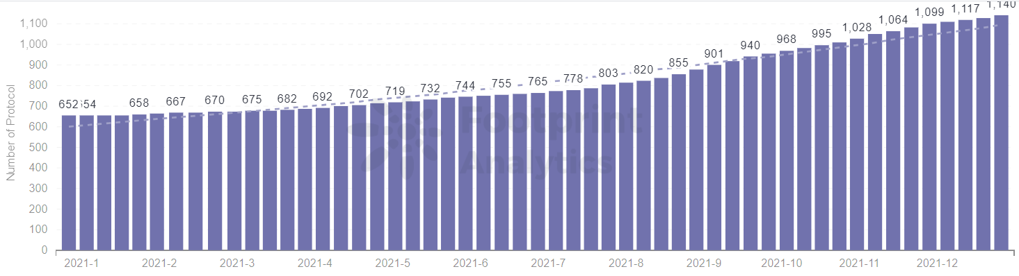

Footprint-2021 Weekly GameFi Projects

1. **GameFi sees surging popularity as yearly transactions increase by 2,934%**

GameFi projects entered the scene like wildfire since March. Google Trends data from early July revealed a significant increase in keyword searches for Play to Earn (P2E) and NFT Games globally. GameFi entered a period of explosive growth as activity on the chain rose dramatically. At this point the number of independent active wallets began to surpass DeFi as the main contributor towards DApp users. The number of transactions then began to stabilize in August, after which point the number of transactions remained high. Peaks in GameFi trading volume were seen on April 9, and December 27, 2021, and the trading volume for 2021 racked up more than $44.7 billion.

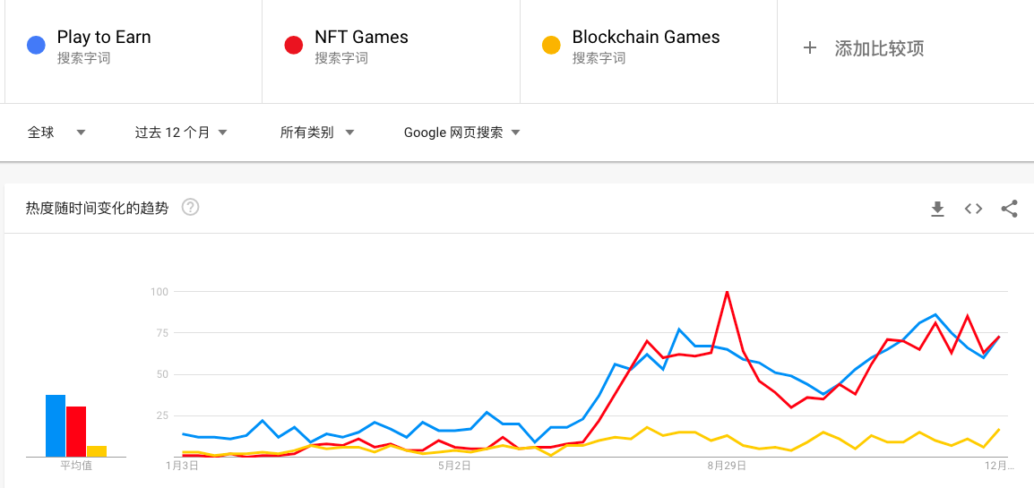

Google GameFi Search Data Trends

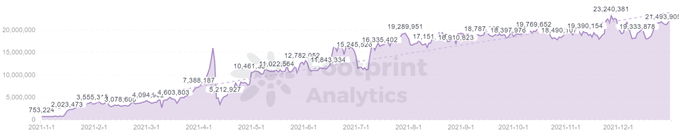

Footprint-2021 GameFi Transactions

1. **GameFi Token is proved to create wealth as it increases in value by a factor of 300**

Axie Infinity, a pioneer in P2E gaming, skyrocketed from 20,000 DAUs (daily active users) in March to 2.8 million at present, with about 105k UAWs connecting to the game each day in Q4 and revenue of over $1.2 billion in the second half of the year, surpassing top Apps such as OpenSea, Uniswap, and PancakeSwap. In November 2021, a virtual piece of land in Metaverse game Decentraland sold for a record $2.4 million, while in December a virtual piece of land on Sandbox sold for a record high of $4.3 million. GameFi concept token prices surged, with GALA soaring to 31,500% over the previous year, AXS to 20,800%, SAND to 14,000%, and MANA to 4131%. The overall market value of the GameFi sector rose sharply, flying above the $30 billion mark for the first time in November, and then hitting $35 billion not long after, setting a new record high.

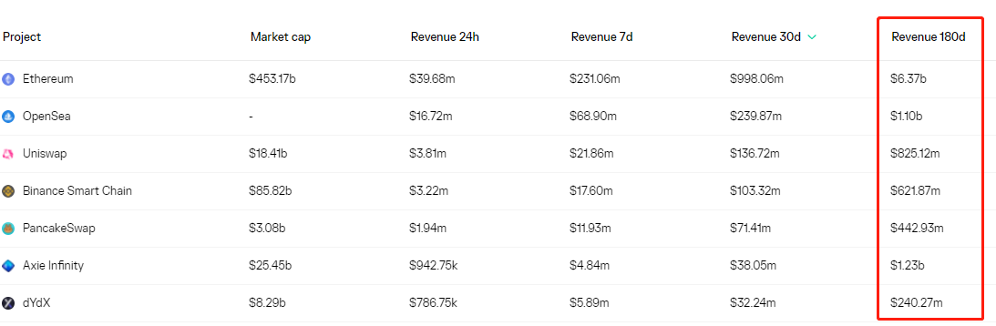

Token terminal-Ethereum DApps Revenue

1. **GameFi NFT secures a place for itself, with annual trading volume reaching 20% of the total for NFTs**

In 2021, the total trading volume of NFTs for the year was $17.175 billion, a 131-fold increase compared to the $130 million in the previous year. NFTs have developed across the gaming, artwork, and collectible industries. Games have become better established and the industries of artwork and collectibles have seen greater diversification.

During the first half of 2021, artwork and collectibles trading were largely responsible for the bulk of the NFT trading volume. In the second half of the year, as GameFi and Metaverse set foot on the stage, game NFTs began to occupy a greater space in the market. Recently, the weekly trading volume for gaming accounts has accounted for 40-50% of the total trading volume. In 2021, the gaming NFT trading volume exceeded $4.5 billion, accounting for 20% of total NFT sales.

The block-NFT Weekly Trading volume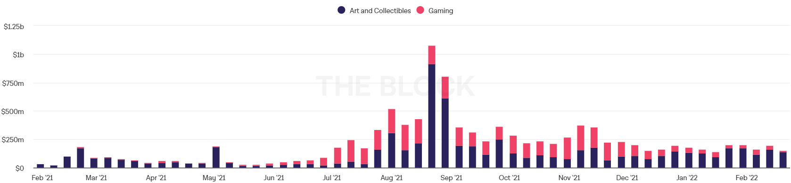

The block-NFT Weekly Trading volume

1. **GameFi gains favor from venture capitalists, raising $4 billion in funds for the year**

As GameFi rapidly develops, major investment institutions pour into the market. GameFi sees a peak in funding in Q4 compared with the previous three quarters, especially in seed funding and B Series funding. Over the course of 2021, GameFi carried out 201 rounds of funding, with funds reaching $4 billion, a 5000% increase YoY. The companies which raised the most funds were Forte ($930 million), Sorare ($783 million), Dapper Labs ($607 million), Animoca Brands ($221 million), Zepeto ($189 million), Sky Mavis ($161 million), and Mythical Games ($120 million).

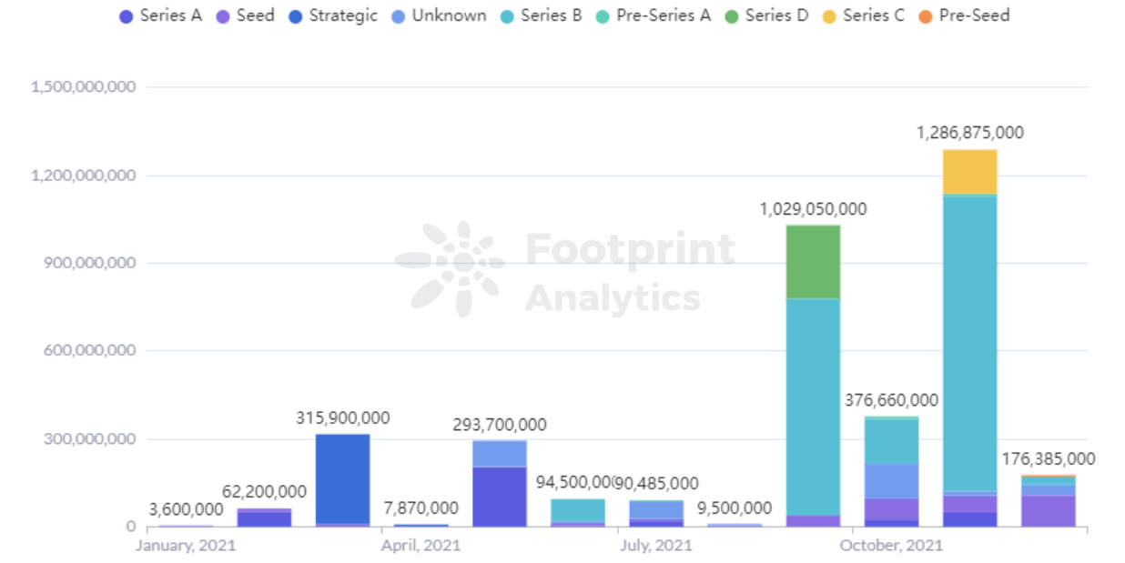

Footprint-2021 Weekly Fundraising

Major institutions, companies, and project parties have launched special funds to further drive the development of GameFi. Gala Games is one example among them, deploying $1 billion for game development in South Korea, French mobile game developer Voodoo is another case, investing $200 million in blockchain games. BSC and Animoca Brands launched GameVest, a $200 million fund for crypto gaming startups, while Bitkraft launched a $75 million fund for GameFi.

### 2．Timeline of Key Events

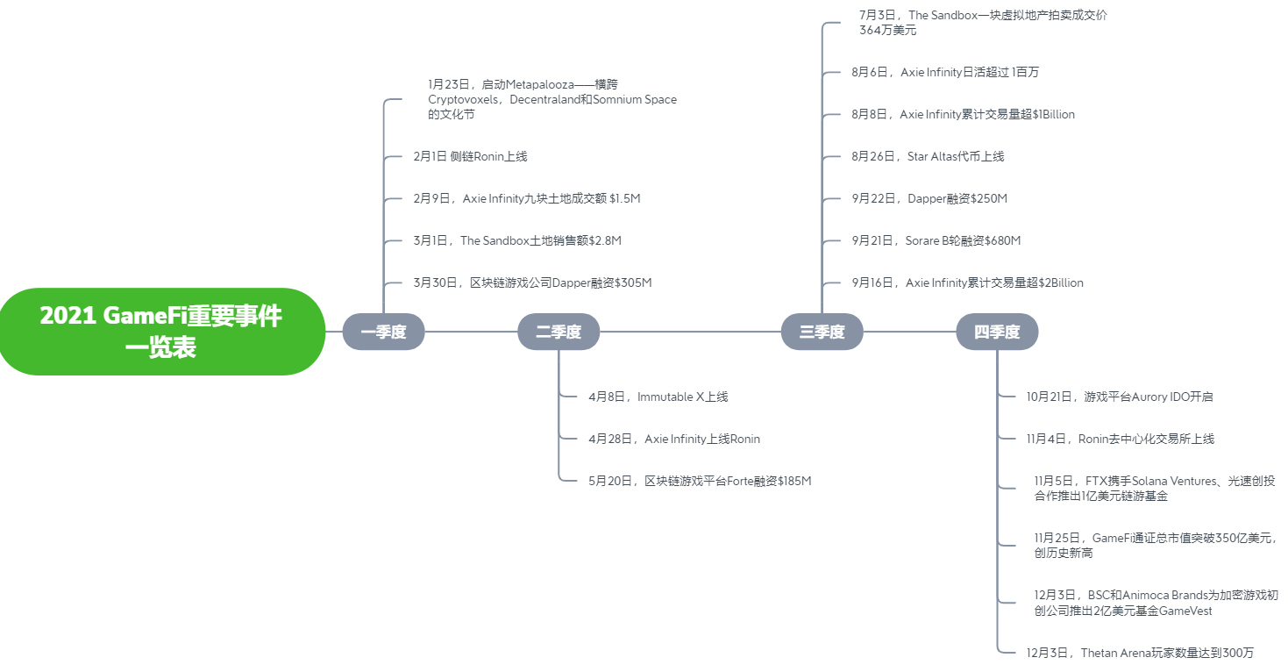

### 3．How GameFi Developed Rapidly

The biggest challenge that exists in the traditional gaming market is the binary structure of participants, with a division between the upstream producers and end consumers, particularly in the great divide in benefits distribution. In more specific terms, the upstream producers mainly include game developers, other IP owners, game publishers, and game distribution channels. Some market participants take on multiple roles in the industry value chain, and in some cases participate in the development, publishing, and distribution of games, even dominating the development of the game industry and accounting for most of the profits generated by the industry. The end consumers, that is, as many as 3 billion players, provide a steady stream of capital investment for the industry, yet, to a large extent, they barely have a true sense of ownership of production materials such as accounts, equipment, or in-game items despite spending a lot of time and money in games. This unfairness needs to be addressed and fixed urgently. While all of these have been taking place, the outbreak of the Coronavirus epidemic in 2020 caused great changes in people's production, life, and entertainment. Some resource-exporting countries and regions, such as those in Southeast Asia, entered an economic crisis due to the epidemic while undergoing economic globalization. Therefore, it became necessary to seek new means of economic growth and ways to export resources in an effort to overcome this crisis.

The economic system that GameFi maps finally delivered the solution to these problems. First of all, NFTs contributed certain benefits, such that every in-game item obtained by GameFi players could have unique, irreversible, and irrevocable "identity verification". This also pleased players by enabling them to be sure about which items and equipment they owned. In this way, NFTs became the underlying technical support needed by GameFi, and players could finally lay claim to the ownership and disposal rights of their game items, and such items may even be able to be transferred between different games. Furthermore, with the emergence of GameFi's P2E model, GameFi players can earn rewards through games, participate in a virtual economy, realize assets in the market, and players can also vote through decentralized autonomous organizations (DAOs) to participate in upgrades and changes to further increase engagement. This presents a more imaginative solution to the problem of trust and balance of interests between game players, developers, and publishers. The different parties no longer have a simple relationship of producers versus consumers, but rather a more equal and harmonious relationship, and this new model allows developers and players to strike more a mutually beneficial relationship.

The emergence of Axie Infinity enabled some residents in Southeast Asia who lost their jobs due to the epidemic to have the opportunity to earn some income by playing games. As guilds were introduced, the difficulty level became lowered, making the process more industrialized and standardized, while generating a more stable player income. Guilds became the perfect link between the project parties and players. They also enabled players to find top quality GameFi projects while providing scholarships and other earning strategies for the players. At the same time, the gaming community required governance, which also relied on the guild for coordination. Most important of all, the game guilds became the gathering place for players to generate initial capital, enabling it to have a greater influence on the GameFi market through a unified layout and overall planning, thus making it a powerful booster for the development of GameFi. In addition, the emergence of the concept of Metaverse also became pivotal in helping GameFi to develop rapidly.

2021 became known as the first year of the Metaverse, a term conceived in writer Neil Stephenson's sci-fi novel Avalanche. This term describes a human being living in a virtual space together with a virtual human through a VR device. This virtual immersive space is parallel to yet independent of the real world. It is an extension of the dimension of human existence where users can carry out cultural, social, and entertainment activities, carrying a real effect on users in the real world. In March of this year, Roblox, the world's largest interactive community and MMO game creation platform was listed on the New York Stock Exchange. The Metaverse mentioned in its prospectus soon set off a huge wave of enthusiasm, thus Roblox became known as "the first Metaverse IPO". On the first day it was listed, Roblox saw its market value reach $45.3 billion on the day of its listing, a 10-fold increase from its $3.9 billion valuation in February 2020. The listing of a company with the concept of the Metaverse not only took off in the technology industry, but also attracted capital and Internet giants to enter this field. In April, graphics card manufacturer NVIDIA announced its proposal for Metaverse business, and in October, Facebook changed its name to Meta to welcome the Metaverse. This craze not only swept through overseas markets, but also Chinese companies such as Tencent, ByteDance, and Baidu jumped on the bandwagon. As online communications permeated into every corner of our daily lives and work, many came to the realization that there really is no need to draw such a clear boundary between reality and virtual worlds, and many problems in the real world can be solved online. Under the framework of the blockchain Metaverse concept, the only way to fulfil the concept of the Metaverse today is to realize the mapping of real systems in the blockchain world. In this way, GameFi, as an extension of the real world and place to hold social gatherings, naturally has become a rather intuitive window enabling us to understand the Metaverse. The total number of virtual land transactions on Metaverse game titles like The Sandbox, Decentraland, CryptoVoxels, and Somnium Space exceeded 6,000 in the final week of November, hitting a total transaction value of $105.8 million. Traditional brands such as Nike and Adidas, and luxury brands like LV, Gucci, and Burberry gradually followed suit by building their own virtual stores in the Metaverse as they foresaw the development of a future Metaverse industry. Thus, the concepts of Metaverse and GameFi not only help to promote each other, but also have an influence on each other.

On the whole, the explosive impact GameFi had in 2021 was the result of a combined effort by many parties. It was a bull market to begin with, full of capital and fervor, where there was a demand to open up new things and increase engagement. DeFi and NFTs provided the precursory fertile soil and ultimate combination allowing GameFi to grow. On top of that, technological development promoted the development of a more vivid imagination, which resulted in the rise of games such as Wax and Harmony which were built on public chains. Axie Infinity was built on a Ronan Ethereum sidechain, while Immutable X, a Layer 2 solution, was designed based on NFT and GameFi, and meanwhile, the concept of the Metaverse was conceived. With the epidemic confining people to indoor activities on a large scale, it was quite inevitable that games would quickly become the entertainment of choice over more general forms of entertainment. If we then project forth into the future, we can see the trend of a future generation of encrypted assets with even stronger financial attributes, better playability and more meme characteristics which will be able to improve our lifestyles, rebuild social and production relations, and even have an impact on a global scale. More importantly, once this trend starts to come into play, to a certain extent, the impact will be irreversible, because while it is happening, the effect carried by GameFi will be dynamic. We have already seen GameFi gradually transform from a pure P2E mode to a mode that combines several attributes such as revenue generation, entertainment, and social interaction.

### 4．GameFi Competitor Development

Currently, there are a total of 1393 GameFi projects distributed across 31 public chains (including Layer 2). The top 5 games by trading volume are DeFi Kingdoms, Axie Infinity, Bomb Crypto, Elfin Kingdom, and Nine Chronicles, which together account for a considerable percentage (77.89%) of the total trading volume in the GameFi industry. Among these, DeFi Kingdoms and Axie Infinity are classic examples, whose trading volumes have reached 26 million and 17.8 million respectively, accounting for 34% and 23% of the total trading volume in the industry. It comes as no surprise that Axie Infinity managed to become the front-runner in the GameFi industry, while DeFi Kingdoms made a late entry, largely owing to its DEX design, which follows a very typical DeFi logic adopting a Uniswap V2 model which allows users to trade tokens and provide liquidity. The gardens in the game provide liquidity in the form of Jewel incentives. The liquidity pool largely consists of Jewels and stablecoin/public chain trading pairs or Harmony One token stablecoin/public chain trading pairs.

DAU is an important indicator in the gaming industry. According to the data from the Utopo platform, the top five games with the highest active users in the GameFi industry are Sprinterlands, Alien Worlds, Farmers World, Crazy Defense Heroes, and NFT Farmer, with DAUs of 345.81K, 213.94K, 106.32K, 89.21K, and 52.75K respectively. Splinterlands is a turn-based card battle game based on the Hive blockchain platform, quite similar to the traditional game Hearthstone, where players collect cards and combine different cards to battle against other players. Winning a game earns you cards and dark energy crystal rewards. Cards can be used in battle, to level up, or can be sold or rented to other players, and the more scarce cards are, the greater the value they hold. Steemmonsters built on the Steem blockchain gradually added elements such as NFT and land auctions as the game was developed, with DAUs maintained at the top 5 spot on Utopo for a long time, largely because it has a fast-paced and automated battle mode and high token distribution on Splinterlands. Generally speaking, the simpler the gameplay, the faster the rotation speed, the higher the yield, and the higher the DAUs. On the other hand, Metaverse games such as The Sandbox and Decentraland have only managed to get DAUs in the double digits.

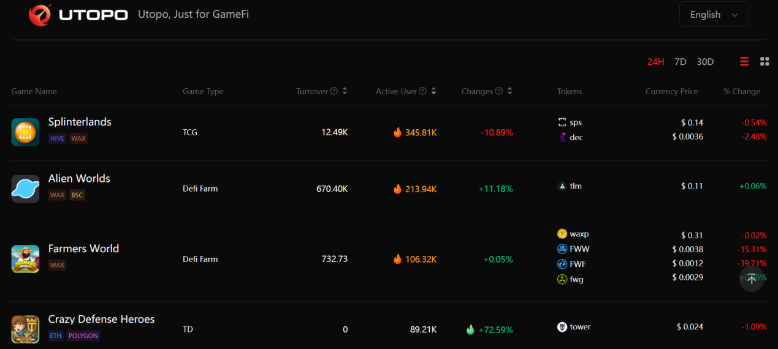

Utopo-GameFi Popularity Rankings

GameFi displays differentiation which is clearly evident at the public chain level. There are 1,393 games distributed on ETH, WAX, BSC, Polygon, Solana, OEC, and other public chains, covering turn-based, sandbox, card, RPG, MMO, and competitive games. Ethereum occupies the top spot on public chain TVL, with absolute advantage, but the transaction speed is slow, and the high gas fees have become an obstacle to its continued growth and development. Conversely, BSC relies on a throughput capacity 6 times greater than Ethereum, low fees, and EVM compatibility on GameFi to generate power and attract more liquidity. Currently, there are 537 games on Ethereum and 442 games on BSC. These two main public chains account for approx. 69% of the games on the market for mainstream games.

Aside from BSC, emerging public chains such as Hive and WAX are also gaining momentum as the GameFi ecosystem develops. The number of games on Polygon, WAX, EOS, and TRON have reached 104, 69, 67 and 62 respectively. Other public chains have no more than 15 games each, such as on Avalanche where there are only 14 games, 3 on Solana and 2 on Fantom, which means the current distribution of GameFi DApps displays an obvious Matthew effect. The existence of such an effect can be understood by taking into account the reflexivity of the low-level and high-level applications on the blockchain. The high-level applications gather on the public chain with good technical experience, a full flow of assets, and more liquidity. The more applications there are on the public blockchain, the more capital there is and the more users there are to carry out optimizations.

From a dynamic standpoint, there are many changes going on behind the scenes in this short-term static pattern. In the past six months, among the top 10 public chains by the number of games, Avalanche has seen the largest increase in the number of games, with an increase of about 450%. The runners up are BSC and Polygon, who have seen a respective increase of about 289% and 168%. For more established public chains, such as Ethereum, the number of games has only increased by about 9%, while for TRON and EOS, no increase has been seen in the number of games.

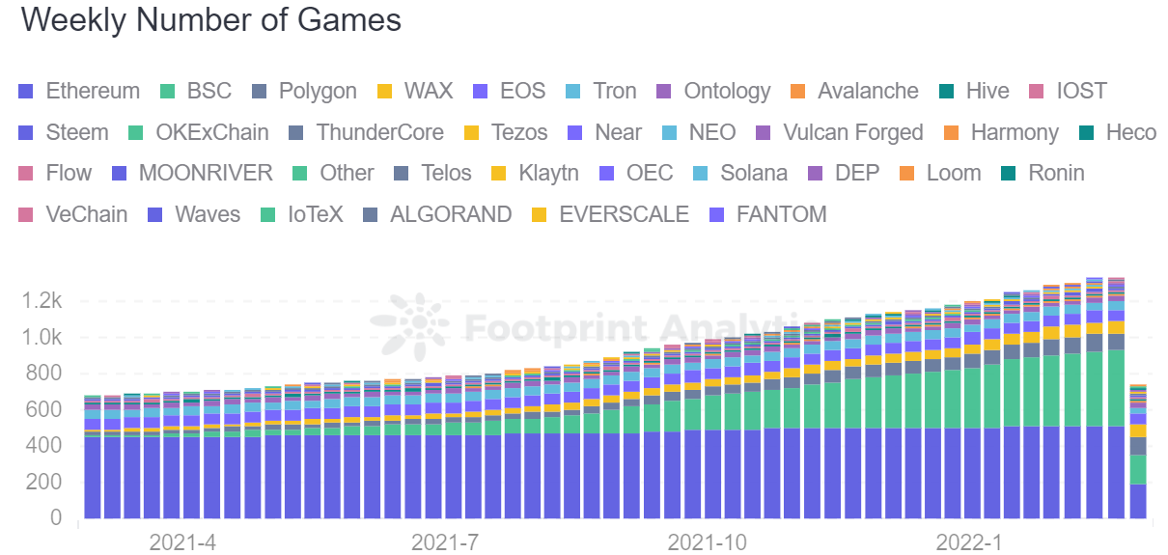

Footprint - Total number of games on the chain

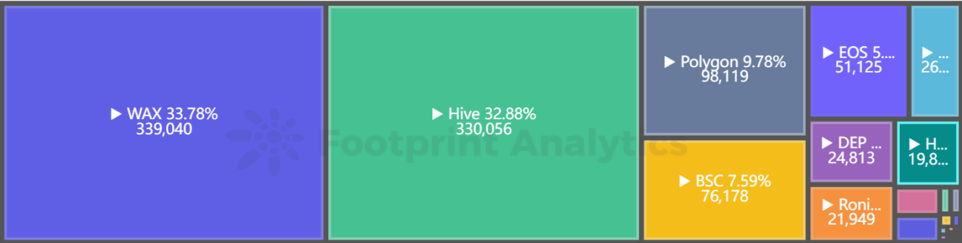

Footprint-GameFi No. of Users

Compared with other DApps, GameFi's high-frequency interaction demonstrates that it pays greater attention to a smooth gaming experience, whereas for other games affected by the high gas fee of Ethereum and congestion on the chain, despite some influential projects, such as The Sandbox, Decentraland, and CryptoKitties still running on it, some have already disclosed their intention to move. New GameFi projects have made an obvious move to BSC, Solana, Polygon, and other public chains. Of course, some of the older games on public chains, such as WAX, are still the most popular choices around.

GameFi has maintained an explosive and stable trading volume, initially on the WAX blockchain, a public chain focusing on in-game items and digital collections, based on EOS transformation and following a Delegated Proof of Stake (DPoS) consensus mechanism, in order to support high throughput required by the game while attracting developers of chain games. The theoretical TPS of WAX can surpass 3,000, and the gas cost on the chain is next to zero. WAX adopts a cloud wallet resource model, where users only need to enter their account name and password to register, without the need for a mnemonic or private key, and purchasing or trading virtual goods simply requires tapping the Confirm button to execute the purchase or transfer, a user-friendly feature for blockchain novices in particular. WAX is officially committed to promoting the interconnection of NFT assets on the chain between independent DApps in the ecosystem, which undoubtedly enhances liquidity and the "life cycle" of assets. Not only that, but the WAX public chain has also invested in cross-chain technologies, something which other on-chain game developers may find attractive. The top three most popular games on WAX are Alien Worlds, Farmers World, and PROSPECTORS, games that are relatively simple in terms of gameplay, and most featuring small games with a puzzle or adventure theme, delivering to a full extent, the P2E element. A sophisticated series of design features are made to heighten the enthusiasm of players to create interest in earning token rewards, increasing the “earnings” in the game to a certain extent, which is the bait that brings in more players.

In the second half of 2021, chains such as layer 2 Polygon and BSC, boasting high performance, low fees, and compatibility with EVM (Ethereum Virtual Machine), attracted more users by leveraging the ecosystem of Ethereum, creating a new sustainable ecosystem for GameFi.

Polygon is a Layer 2 solution of Ethereum, which is just as secure, yet has faster transaction speeds, cheaper gas fees, and is fully compatible with Ethereum (allowing projects on Ethereum to be migrated directly). In the space of 8 or more months on the main net, Polygon's ecology began to take shape, with more than 120 projects, including nearly 40 DeFi projects, nearly 60 GameFi and digital collection projects as well as other types of projects. Diversified ecosystems in niche areas such as GameFi, NFT, and DeFi, especially GameFi and NFT, have developed significantly, attracting the migration of more than a million blockchain game players to the network.

BSC offers the advantages of high speeds, low prices, and EVM compatibility, in addition to launching various incentives to stimulate the development of its GameFi projects. One example of these incentives is seen in the builder program, or "MVB II" in order to stimulate the development of the entire NFT ecosystem. Selected projects could obtain incubation opportunities such as seed funds of $10,000 and support for comprehensive audit fees. In July 2021, BSC announced the finalists, which included GameFi projects, which are popular now, such as CryptoBlades, MyDeFiPet, MOBOX, and X World Games. The next program, or "MVB III" plan, will target GameFi directly. BSC also holds regular global hackathons, and also has launched the Learn & Earn event, and in the current second phase, 4 of the 9 projects in Learn & Earn involve games or NFTs, including CryptoBlades, which skyrocketed in July. In addition, BSC also offers rewards in the form of unique NFTs and bonuses to encourage user engagement in outstanding projects.

## 3. 2021 Classic Blockchain Games

2021 can be said to be the first year of GameFi, a year which was marked by many outstanding games and their explosive success. If the games on the market were classified by traditional gameplay, they would look rather cluttered and chaotic, however here we will classify games from the P2E perspective.

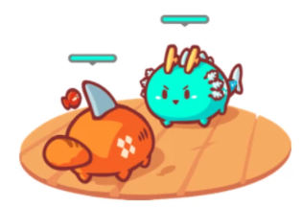**•Win to earn**

Win to earn games emphasize on increasing your win rate to generate a higher token income. Players must defeat opponents, or pass PVE dungeons with high difficulty for a chance to earn more rewards in the form of tokens. This type of game encourages players to consume the tokens they acquired to slow down the huge selling pressure caused by inflation when too many tokens are issued. A classic example is Axie Infinity.

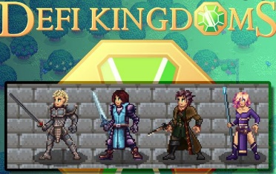**•Stake to earn**

In these games, players hold NFTs or tokens that were officially issued and interact with each other to earn income in the game. The more tokens earned, the more invested capital. However, daily income is capped, and this mode can also be seen nested in other game modes. A classic example of this gaming mode is DeFi Kingdoms.

**•Game to earn**

Game here refers to “gambling” with both winners and losers. This type of gaming mode emphasizes on strategic choices made by the players. If a player makes a wrong move, they may not be rewarded, or could possibly lose money directly. A classic example of this gaming mode is Skyweaver.

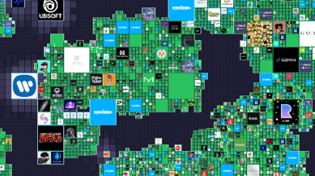**•Invest to experience**

In these games, players do not need to get heavily involved in the gameplay, as it is more like an investment experience. This mode is commonly seen in Metaverse projects. A classic case of this gaming mode is seen in Sandbox.

### 1.Win to earn——Axie Infinity

**1) Gameplay**

To participate in the game, you first need to hold your own Axies NFTs. These are a type of battle pet, and you can get rewards by using these NFTs to win battles. Players can also obtain more income by breeding and trading their pets. Pledging game tokens on the trading platform provides you with liquidity through earning an income in transaction fees.

**2) Capital effect seen as Axie Infinity made breakthrough**

Axie Infinity was developed by the Vietnamese team Sky Mavis. It was a hit in Southeast Asia within just a few months and became popular in China, the United States, and other countries and regions. Its success was accompanied by the epidemic in Southeast Asia, when the unemployment rate increased and people were looking for something to maintain their lives or earn extra income. Axie Infinity met this demand when it was launched and thanks to the support of its guild and the media, Axie Infinity started to skyrocket in June 2021. It generated wealth suddenly in the game industry, outcompeting many phenomenal works of art in the traditional game industry such as Arena of Valor.

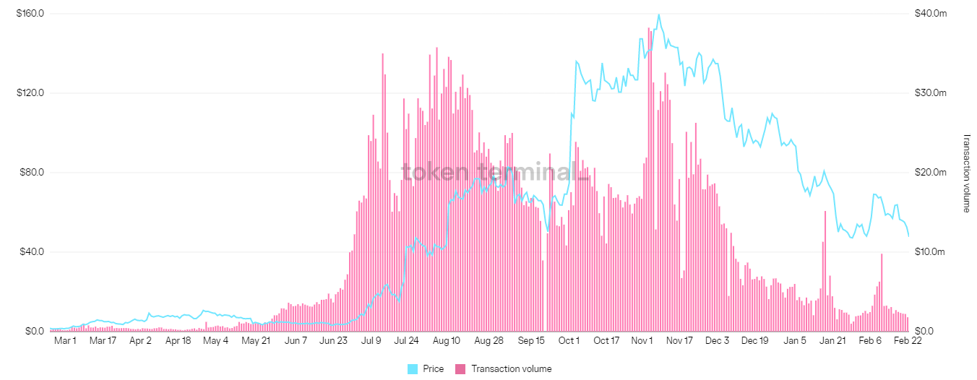

**3) Axie's dual-token economic model**

There are currently 3 tokens available in the Axie Infinity ecosystem, which are ETH, AXS and SLP.

ETH: mainly used for token exchange and liquidity mining pledging.

SLP: These token rewards come in from both PVE (configure pet team for level adventures) and PVP (configure team to join in the arena). However, there is a limit to the daily SLP earned by each account. This is one of the main profit models in the game where players can log in every day to receive SLP tokens made and sell them to recover costs.

AXS: At present, the only way to obtain AXS is through monthly ranking rewards. The only way to consume AXS in the game is breeding, which consumes 4 AXS tokens each time.

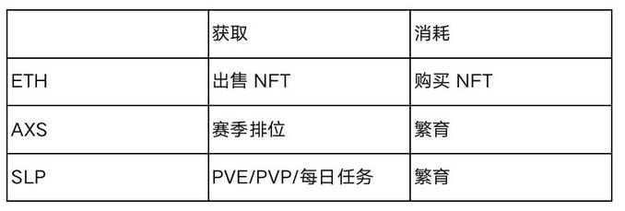

**4) Breeding system**

Both AXS and SLP tokens are required to be consumed for breeding each time. Since the breeding process is simple and easy to operate, the PVE rewards with a higher level of difficulty are harder to find and difficult, and since new players in the market need pets, there is greater market demand for pet breeding, which means that a lot of players opt to breed more pets. Since players spend a lot of their time in PVP, which consumes more energy, players holding NFTs choose to breed pets more. The breeding activity carried out by players tends to use up SLP and AXS tokens, maintaining a dynamic balance in the consumption and output of SLP tokens throughout the game.

However, since the main means of consuming AXS and SLP tokens can only be done through breeding and there is a lack of more application scenarios, once the balance is broken, it could create a reverse trend for the price of tokens. Since SLP itself is a token with unlimited issuance, inflation could occur if the speed of SLP issuance in the market far exceeds consumption. This phenomenon, coupled with “mining, withdrawing, and selling” from retail investors (referring to the process of online harvesting of game tokens, and then selling them for mainstream tokens) will lead to significant pressure to sell, and the secondary market price of tokens will gradually fall.

### 1.1.Win to earn——Thetan Arena

**1) Gameplay**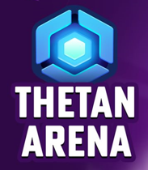

Thetan Arena is an eSports game on the BSC chain where players team up with friends to fight against other players and earn money with their combat skills. Currently, the game is free and each new registered user can acquire a free hero. If likened to traditional games, its combat mechanics are comparable to those seen in Brawl Stars.

**2) FOMO's Mystery Box Sale**

The original way to participate in Thetan Arena was to purchase the official mystery box. As the first batch of mystery boxes was released, the rarest legendary hero mystery boxes got sold out. Although many players know that they can play for free, they were under the influence of the fear of missing out, and the mystery boxes quickly sold out. Players who missed out were only able to purchase them through the secondary market.

**3) Thetan’s Dual Token Model**

THG tokens: Used originally to buy mystery boxes in games, mainly obtained by trading using DEX with other currencies. During those days, buying a mystery box became the only way to consume THG tokens.

THC tokens: Players now can only use gold to purchase these tokens. (Unlocked and available to be sold ten days after account registration.) Alternatively, they can be traded directly by using DEX, and are essentially unlimited issuance of tokens.

Mystery box with heroes: Mystery boxes of different rarities can be unlocked for heroes of different quality. However, there was a potential problem in the early stages of release, where players could easily obtain low-rarity heroes by directly buying mystery boxes, which had lower -earning efficiency and combat strength compared with those of high-rarity heroes. According to statistics, there was only a 27.55% chance that you can make money by purchasing an ordinary mystery box before the game went live and this percentage decreased after the game was released.

**4) Problems with Thetan’s Economic Model**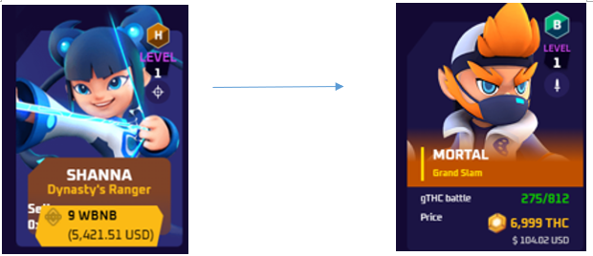

Due to the great level of uncertainty involved in opening mystery boxes, few players tend to use THCs to buy mystery boxes to obtain heroes as they do not know what they are going to get. Meanwhile, the heroes on the secondary market can generally satisfy players for normal gameplay and gold, and player groups who analyze income are more inclined to buy heroes from the secondary market. This will cause the price of the mystery box and the price of heroes in the secondary market to become inverted, making the THC consumption rate very low. Even if the official consumption method that can be used to buy heroes with THCs became launched later, the THC token price would be unable to reverse the downward trend, and such a trend would also affect the price of heroes.

1. **Risks associated with Win to earn**

Economic model risk: A good economic model is key to maintaining token prices. If there is no dynamic balance in play, insufficient consumption of unlimited additional tokens could cause a price collapse.

Timing of buying NFTs (mining machines): Most win-to-earn NFTs have the capability to generate unlimited additional tokens for the game. Given that, and the fact that the price of mining machines always chances, the low liquidity of NFTs could lead to drastic changes in price, and a badly timed investment could cause the asset pool to shrink rapidly.

### 3.1 Stake to earn——DeFi Kingdoms

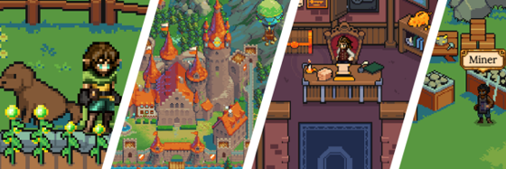**1) Opening the door to DeFi in GameFi**

Decentralized finance is not exactly friendly to new players, because it is riddled with all kinds of blockchain terms as well as incomprehensible protocols and complicated signature authorizations.

DeFi Kingdoms provides players with an easier entry portal into the world of DeFi so that players can experience such jargon through games, such as characters, markets, and gardens in an interesting and vivid, yet concrete way.

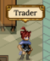**2) Ingenious DeFi Entry Portal**

1. DEX: Trader (merchants) in the marketplace (exchange) can exchange tokens owned by players for any tokens on the Harmony chain.

2. LPpool: Druids can provide funds for tokens that enable liquid mining.

3. Garden system:

Gardens are where mobile mining is done.

Seed Box (liquid pool) is where you can view the interest, income, or other data for each pool, and perform claim and storage operations.

Harvested (seed box) Seeds purchased from Druids can be placed here, and rewards can be claimed after harvesting.

4. Single token pledge: Bank deposits of Jewels used to earn Xjewels.

5. NFT market: This is where the Tavern (hero market) and Agent (hero market) can buy, sell, or rent heroes, while Bareep (the bartender) views heroes or sends them to other players.

6. Pledge NFTs: Once you acquire Professional (working area) heroes, you can send them to work and choose different kinds of working areas based on their occupations.

7. NFT casting: Enter the portal (summoning place) and Arch Druid (grand druid) to choose two heroes to summon, and pay a certain fee to get a new hero. The summoner allows players with only one hero to exchange it for a new hero here. Players can also rent heroes out to earn rental fees.

8. Cross-chain bridges: Enter docks to use ANY SWAP to jump between different chains.

**3) DeFi Kingdoms extension**

Up until this point, there has been no blockchain game capable of running on multiple chains simultaneously while maintaining a large share. DeFi Kingdoms is expected to be such a project, with its first expansion taking place in the first quarter of 2022, when it expanded to the AVAX (Avalanche) blockchain. AVAX currently occupies a larger market cap than Harmony (ONE). Compared with other games, DeFi Kingdoms was expected to take the lead and make its presence known as a mainstream chain.

**4) Blockchain Development Finds Enlightenment Through DeFi Kingdoms**

DeFi Kingdoms has charmed the market with its sophisticated diction and interesting characters and events, which have made it so much easier for the new players to get involved.

DeFi is only a part of the blockchain as a whole, which cannot be simply expressed in a few short sentences. Yet in the future, there may be more complicated concepts and interaction mechanisms that will be conveyed to users through games.

### 3.2 Stake to earn and the fall of its thousand-fold earnings——CryptoMines set sail

**1) Gameplay**

CryptoMines is a mining game where you can pledge tokens. Players initially spend money to acquire "spaceships" and "workers" to form a fleet (mining machine), and then players can complete tasks and pledge more to earn $ETERNAL, its main currency. Players can then use the tokens they gain in the game to continue to buy new workers and spaceships to reinvest and increase output.

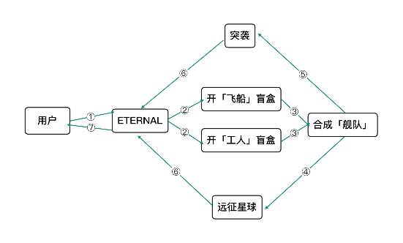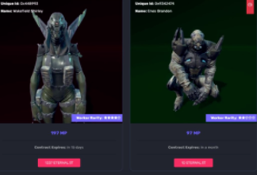

This economic model is simple. Game players and guilds mainly follow the method of "mining, withdrawing, and selling" (harvesting online game tokens every day, and then withdrawing them as mainstream coins) to obtain daily rewards, in as short a time as possible to make back their money.

**2) Fall of the myth**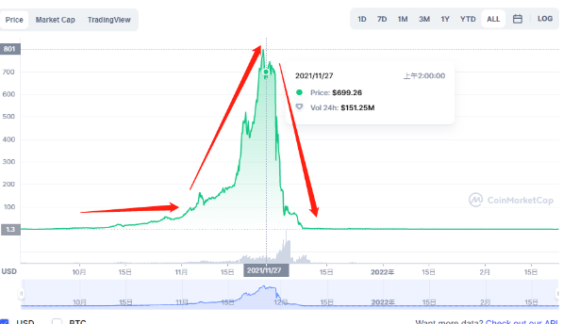

As the GameFi market experienced explosive growth, this spaceship was eagerly pursued by the guild and external funds. As of mid-November 2021, the price of $ETERNAL began to climb rapidly, and a large influx of funds continued to drive the fear of missing out apprehension, which further accelerated the price breakout. Retail investors were attracted by high rates of return, took an interest, and bought up a large number of mining machines and tokens. After the main capital had left the market, the bubble then burst. Many ordinary players were left with only some useless tokens and mining machines. The low trading volume meant that players had to sell at any cost to leave the market. A reverse trend set in as the token price went down for less than three days, after which the token price had bottomed out before retail investors even scramble to respond. The return of many high-level funds became a long-lost prospect.

### 4.Game to earn——Skyweaver

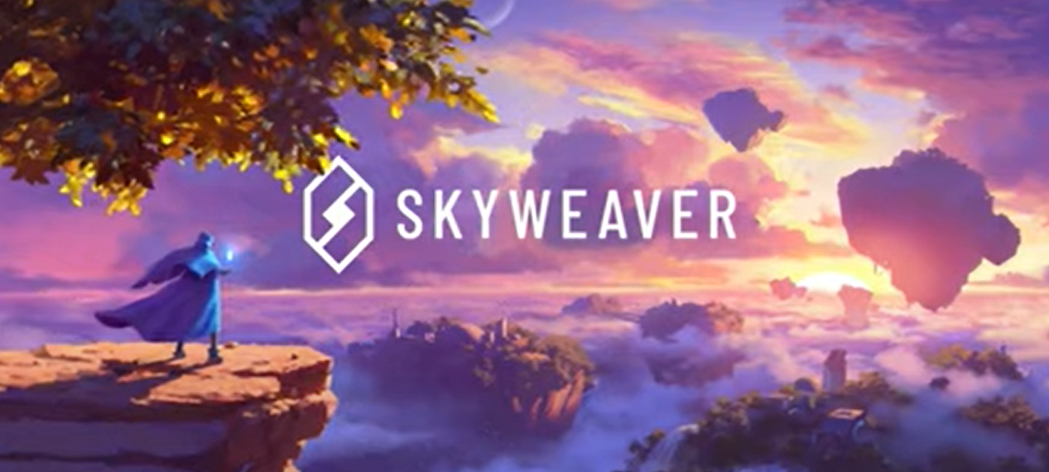

1. **Gameplay**

Skyweaver is a free trading card game in which the player controls a hero and fights the enemy by building their card deck. When the health of the enemy hero is exhausted, a round of the game is won.

**2) Emphasize on game participation as means of survival**

Skyweaver is a competitive game where players need to change different strategies to build their own decks, and find ways to defeat opponents to get richer rewards. For players with more experience, they are more willing to take on difficult battles, because they can get richer rewards after winning.

In most blockchain games you need to buy in-game NFT items or tokens to start participating in the game, but in Skyweaver, players only need to create an account to play for free.

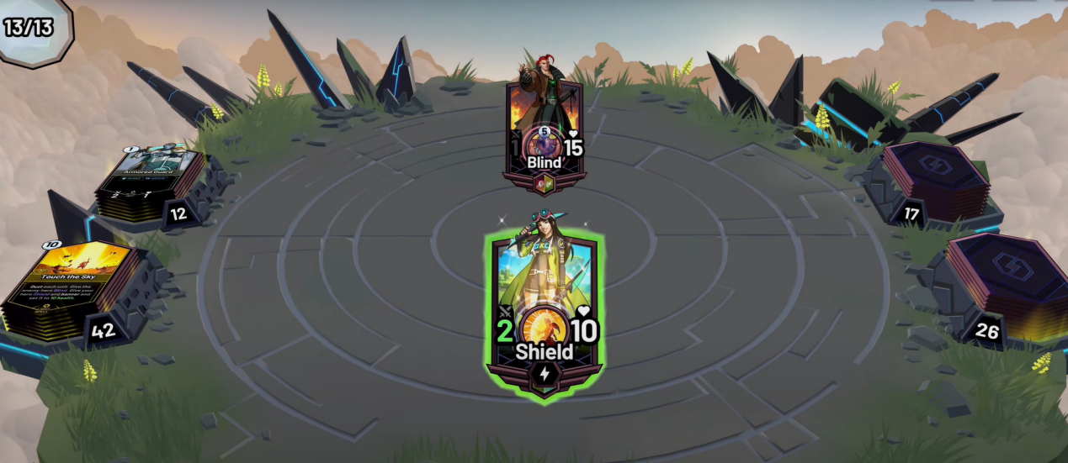

Simplified battle UI

Unlike traditional games such as Hearthstone and Artifact, Skyweaver makes NFT cards that are owned by players. In traditional card games, players' cards and heroes are obtained mainly through opening mystery boxes to draw cards. Since these cards cannot be traded through the market, some out-of-print hero cards can only be exchanged by players by selling their game accounts. In TCG games, players who hold expensive and rare cards lay in wait for their cards to gain value as they get widespread attention. By making the card data truly owned by the player, the cards can be identified by addresses as assets. This not only solves the problem of fair value of the card, but also makes it easier for players to trade.

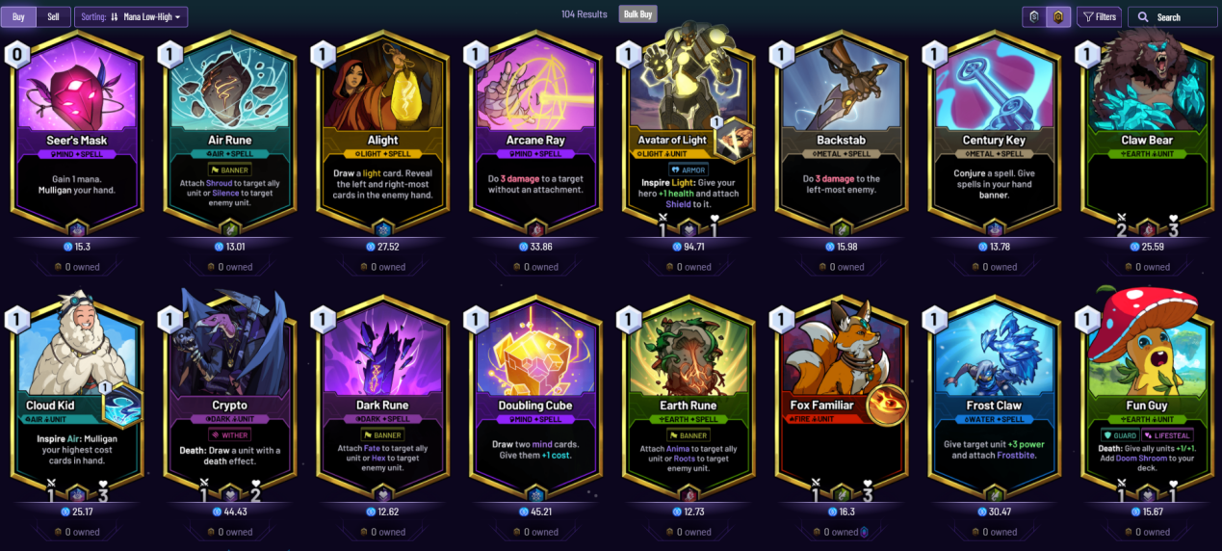

**3) Skyweaver presents another perspective on Game to earn**

These games feature low barriers to participation, no fees, and tokens that can be earned by investing more time in playing the game. This means that players do not need to undergo a significant amount of financial pressure to experience a game, a big advantage from their perspective. NFTs that cost thousands of dollars are not necessarily affordable for quite a few players.

Skyweaver provides a good prospect for future TCG card games or other competitive games. As GameFi saw explosive growth over a short space of time, Skyweaver managed to gain a firm foothold and is expected to become an outstanding representative game of this genre in 2022.

### 5.1 Invest to experience——Big Time

1. **Gameplay**

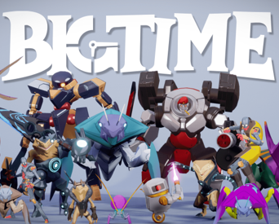Big Time is a Multiplayer ARPG (multiplayer action role-play game), where players may create their characters, choose races, skills, explore maps, and accomplish various community activities such as joining teams, battling, production, and trading. The world of Big Time is not subject to a certain era. In this game, players need to travel among different civilizations and timelines to collect NFTs, which are used to enhance their characters or obtain rare skins. Everybody may customize their portal, while rare NFTs give portals a cooler look.

1. **The Land System in Big Time**

The SPACE NFTs in Big Time come in with various sizes and rarities. A bigger and rarer SPACE supports more functions. Bigger and rarer space upgrades allow players to build more forges and summon more Time Guardians, which is a critical step for obtaining tokens. The playable area of all SPACE can be expanded. Players may decorate or redesign their SPACE as needed, or connect multiple SPACE together to customize the layout of their Time Machine (player-owned land).

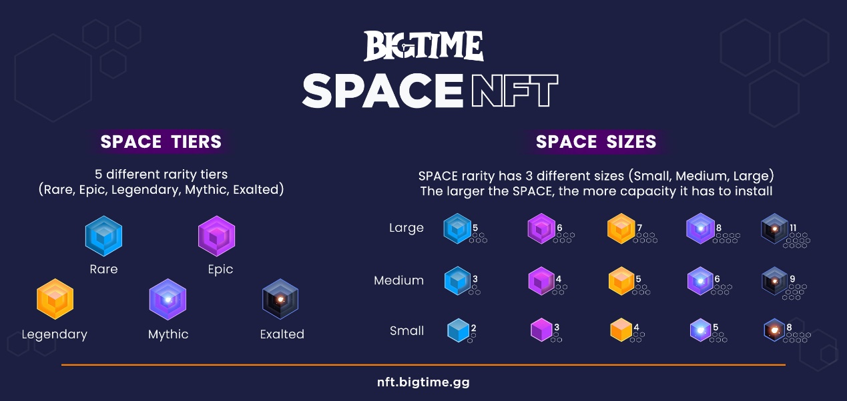

1. **The Highly Maintained Value of Lands in Big Time**

At the end of December, 2021, the first batch of Lands was distributed in Big Time, taking up 10% of the total circulation. These were called the Land Opener NFTs. The rarest exalted Lands were immediately bought out within the first hour, after which investors shifted their attention toward mythic-tier Lands. Later, even legendary-tier and Lands of lower rarities were sold out within that week. At that time, the issue price of an exalted Land, the rarest tier, was 3,500 dollars. Till now, the floor price of every exalted Land has been maintained at around 25,000 dollars.

### 5.2 Invest to experience——The Sandbox

The SandBox is a decentralized blockchain-based game developed by Pixowl, released on May 15th, 2012. In The SandBox, players may create items, artworks, toys and so on. Everything created this way is an NFT owned by a player, which can be auctioned on the market. Players who have played Minecraft before will find these two games much alike.

The SandBox consists of these three major elements:

•Game Tokens(SAND): necessary for participating in the game. They can be used for trading, pledging and administration.

•Game Lands(Land): lands to be used in the game. There is a maximum of 166,464 blocks of lands.

•Game Assets(Assets): tradable NFT items such as equipment and trinkets.

**The use of SAND:**

•Purchase Lands, items, visit Lands owned by others, play mini-games, and so on.

•Used as administrative currency in The SandBox.

•Pledge to earn more SAND.

LAND is the unit of the lands in the game. There is a total of 166,464 blocks of lands in The SandBox, and each LAND is an NFT, meaning that every LAND has its ownership and can be traded. Moreover, it will be permanently kept and logged in the game.

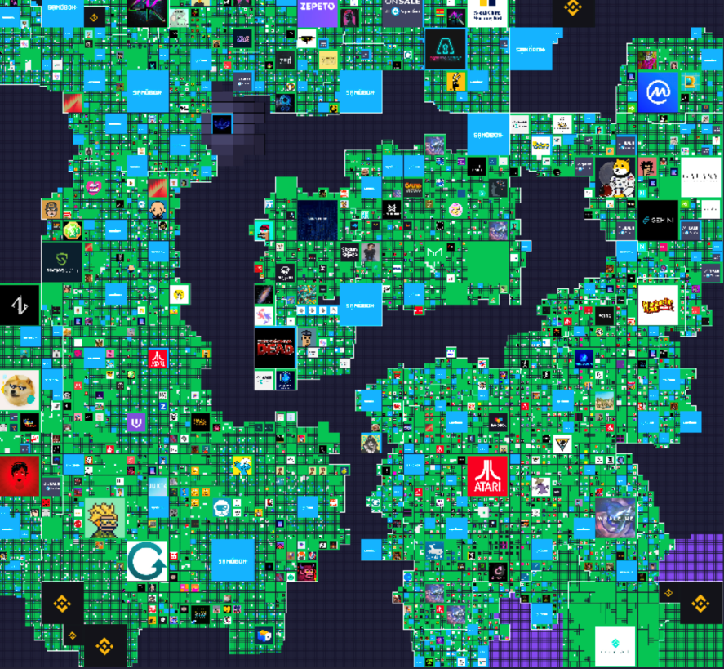

The World Map of The SandBox

Upon careful observation, one may notice that some of the LANDs are exceptionally large. Here is why. A player who owns multiple LANDs may combine them into an Estate. For example, when 9 LANDs are combined, they become an Estate of 3x3 size.

**The Cultural Symbol of Sandbox Virtual Assets**

Those larger land blocks are just like the landmarks in real life. Imagine them to be the CN Tower, the Dubai Tower, or even a pyramid. When a player owns a piece of land in a Metaverse full of celebrities, social activities, and cultural intersections, it is just like owning their land in real life, when the prices of these lands keep rising.

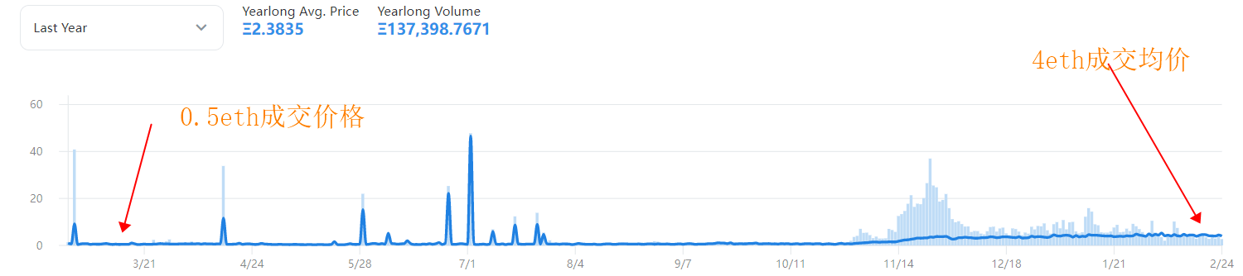

Since the beginning of the last year, the average transaction price of Land has risen from 0.5eth to the current 4.5eth, achieving almost a tenfold ETH standard rise. Not to mention the surge of ETH price since the beginning of 2021, which has risen from around 1,400 dollars to around 3,000 dollars (March 1st, 2022).

This means that, even though the player-invested lands in The SandBox have not entered open beta, the average return rate of holding land projects is well above 2,000%. This is an insanely high rate even for investments in real life.

As such circumstances are known by an increased number of people, Land has become akin to real estate in the world of blockchain, recognized by many.

**Why Metaverse assets appreciate so crazily?**

1. Adjacent geological space --- different institutions are linked together, leading to a constellation effect similar to Wall Street and Silicon Valley, and driving the price of corresponding lot high. In the Sandbox, for example, the lots closer to the downtown area of Sandbox generally cost higher.

2. Decline in DeFi earnings and FOMO sentiment causes the capital to seek new outlets.

3. The proposal of Metaverse concept has drawn the attention of the public. The expectation for the application of virtual lands like Sandbox is getting higher.

4. The attribute of NFT of land itself results in low liquidity. Delist effect will generate upon consensus, and the price can get high without too much trading volume in the demand-supply change.

## 4. Future of GameFi

From May 2021 to early 2022, the whole cryptocurrency market has experienced many twists and turns, and there are also many GameFi games that have experienced life and death, many of which have become a thing of the past, while there are also the best who have survived.

1. **P2E May Become a Future Career**

Players involved in AXIE made a fortune in 2021, and there were many who have chosen to form studios and shared the benefits through collective labor. Early players chose P2E games most likely as they knew the game could be profitable. Although many media claimed that most of the games are financing traps, there were still many players involved. From this, we can conclude that the game led by “earn” is more like a gambling game, where the game between retail investors and bankers determines the rise and fall of the market price. In the future, there may be a more detailed division of work in the GameFi, players can experience new jobs in the game to obtain a livable wage. But such a product may not simply be called a game, it is more like a new model of work that affects the distribution of social production.

**2. Game Developers' Shift of Perspective**

If we want to achieve real P2E, game companies and investors have to think about many things.

First of all, where do the revenues of those players who made a fortune exactly come from? After Axie ignited the boom, there are a lot of games that are actually enjoying industry dividends and project pie expectations, and they are feeding early entrants with money from new players and secondary markets through time lags. The second is that the new P2E model needs to consider how to improve internal operational efficiency. Developers may use more blockchain technologies and try new collaboration models to achieve cost savings. After that, more project parties may adopt to hand over the work of expanding the market to the community to govern, and distribute rewards to outstanding community contributors depending on the promotion results. In addition, the game companies may show more sincerity in the game P2E allocation by rewarding those full-time game players and encouraging them to become professionals. Investors and game developers should promote professionalism and work together to start global professional competitions. Lastly, the project parties need to consider a more reasonable reward and punishment mechanism to balance the difference in rewards between the studios and ordinary players, such as adopting a random and fair matching system, etc.

**3. What Does the Advent of Metaverse Mean**

In 2022, there are many Metaverse games that are not officially launched, such as Sandbox, Big Time, etc. But what kind of games can be considered as Metaverse games? There are many characteristics that a Metaverse should contain. A well-known angel investor Matthew Ball defines a Metaverse as a virtual realm with the following seven characteristics.

1. Persistence (a permanent, always open global gathering)
2. Vividness (similar to the physical world)
3. Coexistence of uncapped users
4. Economic robustness
5. Relevance across the digital and physical worlds
6. Interoperability (portable goods, identities, IP, etc.)
7. User-driven evolution (content and experiences are created publicly instead of a centralized company)

It is difficult to grasp intuitively by such a definition only, as we might illustrate with an example.

Firstly, assuming that there is a completely open virtual world, players can access this totally different place from the real world at any time via their wearable devices (such as your VR body device, a PC, or a phone). Secondly, the real-world physical rules for interaction are also applicable to players in this world, while this world is not constrained by the number of people, and can have billions or even tens of billions of people online at the same time. In such a world, players have a unique identity, a new customized appearance, and players can spend more money to make themselves different. Players perhaps have a completely different job from the real world in such a parallel world, a brand new partner or even a marriage partner. Players can also create their content and share it, thus earning income through these actions. However, the time players spend in the Metaverse should be synchronized with the real world, which means that the time spent in the Metaverse is consuming real-time.

A stable and mature Metaverse may be completely separated from reality, which means that there will be a new society, a new system, where people may be able to find new jobs and a new direction for their lives, and the reality will only be simple things like eating, easy socializing, sleeping, and exercising for them.

It is clear that the Metaverse games we have access to so far have not reached the above scenarios, but they are perhaps the earliest prototypes of Metaverse. As each sub-universe gradually merges into a real Metaverse, more surprises and experiences will surely come.

## References

1.DeFi Kingdoms Official White Paper: Introduction to Garden Liquidity Mining Mechanism

2.<https://www.tokenterminal.com/> Axie infinity Annual Trading volume Chart

3.<https://coinmarketcap.com/> Eternal Price Trends Chart

4.Big time Official White Paper: Game Introduction

5.Sandbox Official White Paper: Game Mechanism

6.Opensea Platform Trading volume Chart